Enzymes at a glance
Edith Jiménez-Muñoz¹ Justo Fabián Montiel-Hernández² Alberto N. Peón^{1,3} Aldo Christiaan Jardínez-Vera¹ Pablo Antonio López-Pérez¹
¹ Escuela Superior de Apan, Universidad Autónoma del Estado de Hidalgo. Carretera Apan-Calpulalpan s/n, Colonia 43920 Chimalpa Tlalayote, Hgo, México.
² Escuela Superior de Ciudad Sahagún, Universidad Autónoma del Estado de Hidalgo. Carretera Ciudad Sahagún-Otumba s/n, Zona Industrial, 43990 Cd Sahagún, Hgo.
³ Laboratorio Santiago Ramón y Cajal, Sociedad Española de Beneficencia, Pachuca, Hidalgo; Av. Juárez #908, Col. La Villita, Pachuca, Hidalgo, México, CP42060.

Abstract
Enzymes are found in nature as part of living systems and perform essential functions for nature.
Enzyme technology is an interdisciplinary field recognized by the Organization for Economic Cooperation and Development (OECD) as an important component of industrial development. Processes involving industrial processes, pharmaceutical development and discovery, genetic engineering.

Highlights

Enzymes are essential for life to exist.
Enzymes are biological catalyst that provide an alternative reaction route and stabilize reaction intermediates
Reduce activation energy

Keywords

Enzymes, catalysts, substrate, Michaelis-Menten kinetics

What are enzymes?

Enzymes are protein catalysts that speed up the rate of chemical reactions in living organisms. In the absence of an enzyme some reaction would take longer than the age of the universe (1) Enzymes are biocatalysts that, under mild conditions of cell temperature, pH and pressure, carry out chemical reactions at a rapid rate. They are characterized by high regioselectivity and specificity (2,3,4).
These enzymes act on specific compounds called substrates, which are converted into products at very high reaction rates. (5).
Enzymes can be named by adding the suffix "ase" to the name of the substrate such as urease, which catalyzes the hydrolysis of urea (substrate), DNA polymerase, which catalyzes the synthesis of DNA; they can also be named conventionally without reference to their substrate such as salivary ptyalin, gastric pepsin, pancreatic trypsin and chymotrypsin among others. This nomenclature system often caused great confusion, which led the International Union of Biochemistry and Molecular Biology (IUBMB) to propose a classification system based on the reactions catalyzed by each enzyme. (4). According to this enzymes classification are divided into six types (table 1) (1,4):
Table 1. Classification and function of enzymes used in industrial processes.
Class | Function | Industrial enzymes
Oxidoreductase | catalyze redox reactions | Catalase, glucose oxidase, laccase
Transferase | catalyze the transfer of a group of atoms, such as amine, carboxyl, carbonyl, methyl, acyl, glycosyl, and phosphoryl from a donor substrate to an acceptor compound | Fructosyltransferases, glucosyltransferases
Hydrolase | catalyze the cleavage of C─O, C─N, C─S, and O─P bonds by addition of water | Amylases, cellulases, lipases, mannanases, pectinases, phytases, proteases, pullulanases, xylanases
Lyase | catalyze the cleavage of C─C, C─S, and C─N bonds (excluding peptide bonds) in a substrate by a process different from hydrolysis | Pectate lyases, α-acetolactate decarboxylases
Isomerase | interconvert isomers of any type: optical, geometric, or positional | Glucose isomerases, epimerases, mutases, lyases, topoisomerases
Ligase | catalyze the bonding reaction of two large molecules by the establishment of a new chemical bond | Argininosuccinate glutathione synthase

Enzymes in the industry

The use of enzymes in various processes has been known for a long time. Historically, the first records of their use date back to ancient Greece, in the use of microorganisms for the production of bread, alcoholic beverages, cheese and other products (6). The enzymes reduce activation energy required to reach the highest energy transition state of the reaction, are proteins that accelerate the process of specific chemical reactions (7):
Each enzymatic reaction is composed of two basic steps (Figure 1):
1.- the reversible binding of a substrate to an enzyme.
2.- a catalytic step that results in the formation of a product.
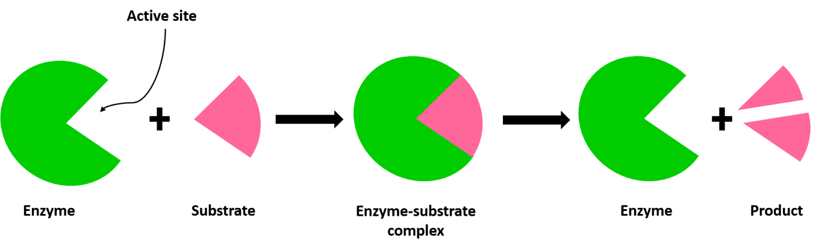
Figure 1 Mechanism of enzyme activity
These reactions are the basis of metabolism in all living organisms and provide great opportunities in diverse areas of research.
Due to a better and greater understanding and purification of enzymes and to the knowledge of their high specificity and the mild conditions at which they can operate, as well as the minimum amount of waste they can generate in their processes, the number of applications of these enzymes has increased considerably.
The use of enzymes in industry shows a viable alternative to improve and make industrial processes more efficient and reduce or avoid the use of toxic chemical products that damage the environment, being enzymatic processes a viable and sustainable option for the benefit of society.
It should be noted that only 5% of chemical products are produced biologically, despite the fact that there are more than 3000 enzymes, of which only 150-170 are used in industry. Currently, enzymatic processes are a great opportunity to change or combine physicochemical and mechanical processes, offering a high economic and sustainable viability. (1).
In this regard, we can emphasize that industrial processes use large amounts of water, as is the specific case of the textile industry, which uses more than 70,000 liters for the production of one ton of product; 9 million tons are produced in the world, so if enzymes were used, more than 630,000 million liters of water could be saved, which is another interesting fact for using enzymes in the processes.
Research focused on the use of biological catalysts has increased due to the negative impact on the environment, seeking sustainable alternatives for the production of chemical products (green chemistry) and complex active ingredients, often in the pharmaceutical and agro-biological context.
The implementation of enzymatic processes is extremely attractive for industrial purposes because in addition to working under mild conditions, they minimize the generation of toxic waste; however, it is pertinent to mention that not all biological catalysts work at industrial level.
There are a large number of enzymes among which we can mention the following that are used at industrial level.
In the textile industry cellulase, laccase and azoreductase are used; in the food industry phytase, α-amylase, glucose oxidase, renin, lactase enzymes are used; in the pulp and paper industry the enzymes cellulase, xylanase used, Detergent industry are used catalase and cellulase and in the Chemistry and Pharma Sectors the glycosyltransferases, currently few basic chemicals, such as acrylamide, are produced by enzyme technology. The use of enzymes in industrial processes has increased because they represent greater economic viability and process sustainability due to the fact that low-cost renewable substrates can be used as raw materials (1,9,10,11).

Michaelis-Menten kinetics

In 1913, Leonor Michaelis and Maud Menten published in their landmark article on enzyme kinetics the results of their studies on sucrose hydrolysis by invertase, they studied how a two-ring sugar (sucrose) is hydrolyzed by an enzyme derived from yeast invertase (b-D-fructofuranoside-fructohydrolase (o-b-D-fructofuranosidase) whose code is EC 3.2.1.26) figure 2.
The research was based on a novel experimental design and a mathematical model. It is worth mentioning that despite not having established the protein nature of the enzymes and before complexes with substrates could be detected, the results on enzyme kinetics provided a quantitative view of the biochemical kinetics. Michaelis-Menten kinetics provides a solid framework for in vitro enzyme kinetics.
These variations in the rate at which an enzyme binds are altered by substrate concentration. To this end, the fundamental formula proposed by Michaelis-Menten (MM) describes how the rate of enzyme catalysis depends on the substrate concentration, i.e. it arose from the need to explain in a simple and mathematical way the behavior of an enzyme (16,17,18).
As can be seen in the graph (figure 3) obtained from Web of Science, the use of the Michaelis-Menten equation is still in use today. This is due to the fact that in areas such as biochemistry and molecular biology, mainly, there is a substantial interest in the study of biological systems and the study of individual molecules for drug development, where special attention must be paid to the kinetics that are performed (19).
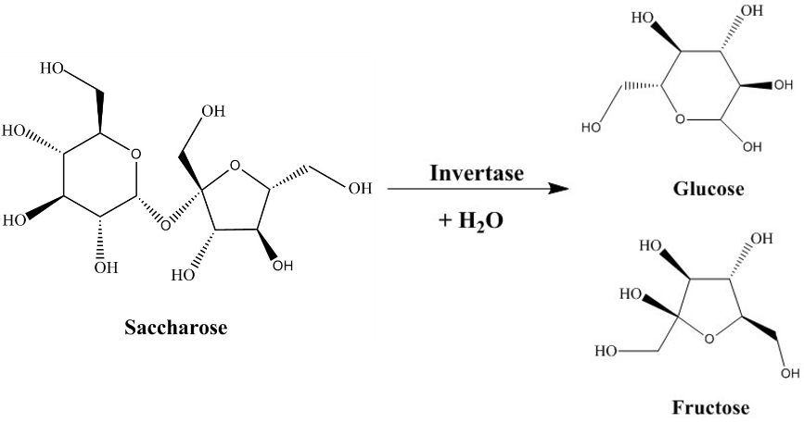
Figure 1. Sucrose hydrolysis by invertase.

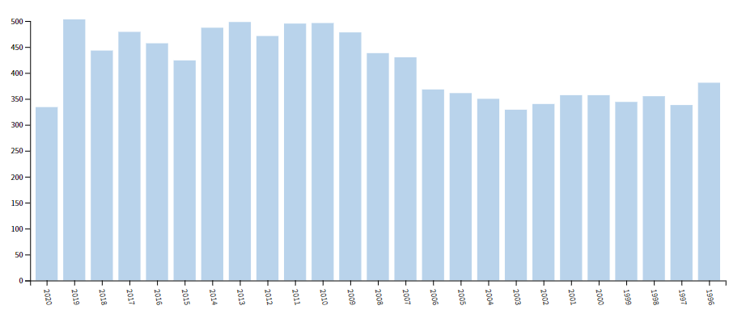
Figure 3. Number of publications for Michaelis-Menten (1913). Data were obtained from Web of Science on September 29, 2020.
Enzyme technology is an interdisciplinary field recognized by the Organization for Economic Cooperation and Development (OECD) as an important component of industrial development. Processes involving industrial processes, pharmaceutical development and discovery, genetic engineering (20).
The kinetics in this type of reactions is not linear at all points, since it does not maintain a proportionality throughout the biochemical process (Figure 4).
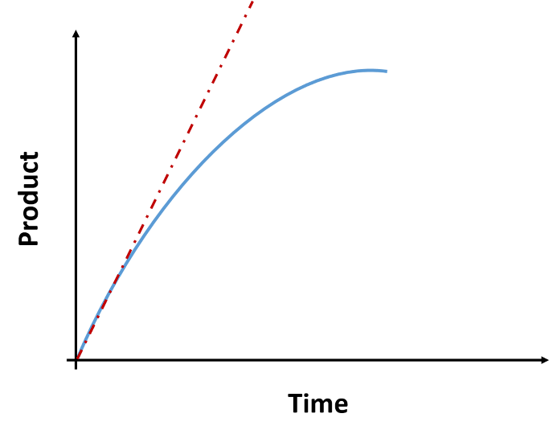
Figure 4 Graphical representation of an enzymatic reaction.
The kinetic behavior in a biochemical process can be given by the following considerations:
Depletion of the substrate.
Increase of the product concentration ([P]) with respect to time.
Denaturation of proteins during the catalysis process.
To avoid this loss of linearity with respect to the time elapsed in the reaction, the tangent is always plotted at a time (t = 0) and from this the initial velocity of the reaction is calculated. We can also see that the initial velocity of the reaction always presents a proportional area between the elapsed time and the amount of product formed.
There is a directly proportional relationship in terms of product formation with respect to time (the amount of product increases as time elapses), while the relationship between the amount of substrate is inversely proportional, i.e. as time elapses the substrate decreases.
According to Figure 5, we can say that:
During the time interval from t1 to t2 the amount of total enzyme (TE) drops to very small values and remains constant, after this time it starts to vary.
The amount of the enzyme-substrate complex ([ES]) at time t1 stabilizes until time t2, after which it begins to decay.
The amount of free enzyme is very small but never reaches zero.
The amount of the initial substrate concentration ([S]0) is much greater than the concentration of the total enzyme ([ET]) present in the medium.
The constant behavior of the enzyme-substrate complex during times t1 and t2 is known as steady state.
The steady state refers to the rate at which (V_{f}) the enzyme-substrate complex is equal to the rate at which the enzyme disappears. (V_{d}), that is why we say that its concentration is a function of time.
The steady state can be represented by equation number 1.
$$v_{f}=v_{d}……………………………………..Eq. 1$$
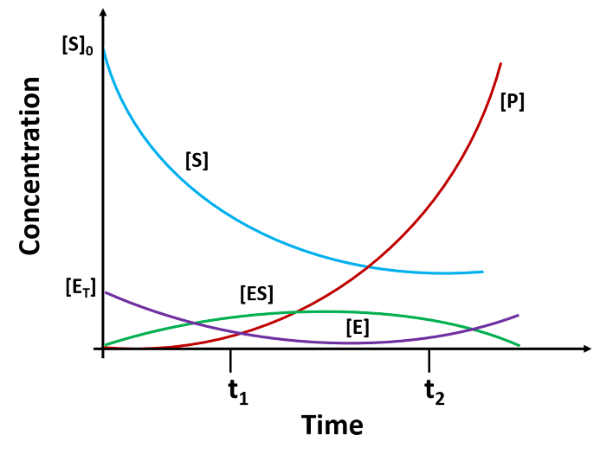
Figure 5. Graphical representation of the time course of an enzymatic reaction.
As shown in Figure 6, enzymes have a rectangular hyperbola type graphical response, from which we can deduce that:
As the substrate concentration increases, the rate of the reaction at any point (V₀) The speed of the reaction increases until it reaches a point where it stabilizes and becomes the maximum speed of the reaction (V_{máx}).
Thus, at low substrate concentrations there is a proportionality between the substrate concentration and the instantaneous rate of the reaction.
In the zone of the maximum velocity this becomes independent of the substrate concentration, since experimentally it is denoted that as the substrate concentration increases, the initial velocity of the reaction practically does not alter.
The substrate concentration at which half of the maximum velocity is obtained is extrapolated on the curve and is equivalent to the Michaelis-Menten constant (K_{m}).

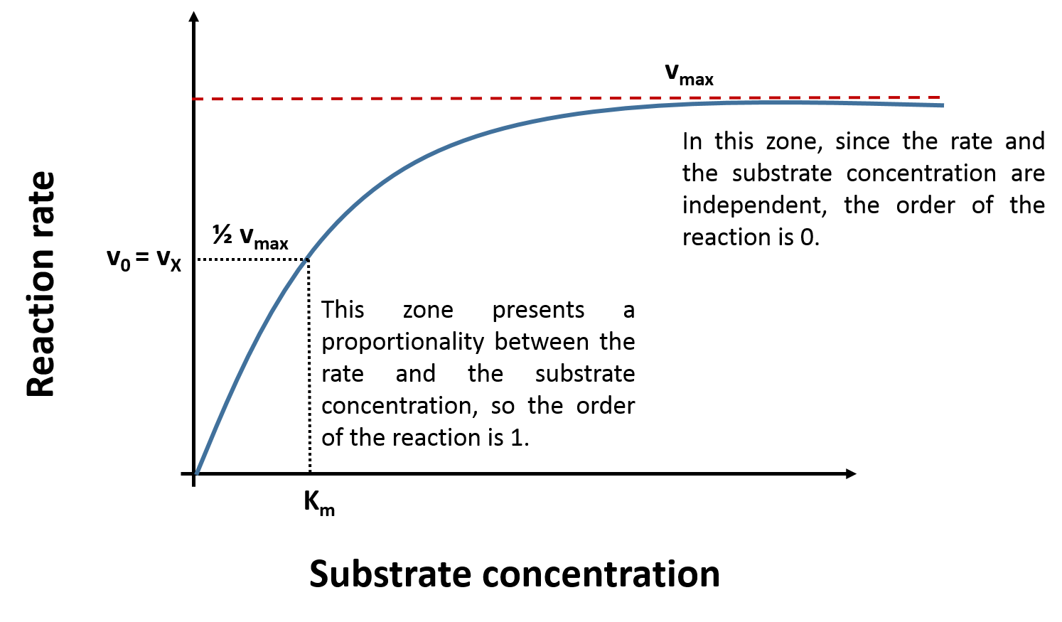
Figure 6 Graphical representation with respect to the Michaelis-Menten constant, which describes the kinetics of an enzymatic reaction.
The catalyzed reaction proceeds in two stages: in the first stage, the enzyme (E) binds reversibly to the substrate (S), forming an enzyme-substrate complex. In the second stage, the product (P) and the enzyme (E) are released, as shown below.

$E+S\begin{matrix}\underset{→}{{ K}_{1 }} \\ \overset{←}{{ K}_{-1}}\end{matrix}ES\underset{→}{{ K}_{2 }}E+P$ ………….Eq. 2.

- In order to elucidate a formula relating enzyme, substrate and product concentrations to speed, Michaelis and Menten established the following conditions:

Total enzyme (E_{T}) present in the medium is equivalent to the sum of the free enzyme (E) plus the enzyme of the enzyme-substrate complex (ES).

$\left[E_{T}\right]=\left[E\right]+\left[ES\right]$ ………….Eq. 3.

- The catalytic constant K₋₁ is comparable to the catalytic constant K₂. That is to say that once the enzyme-substrate complex (ES) is formed, there is the same probability to return to enzyme plus substrate (E + S) or to pass to enzyme plus product (E + P), that is to say, it does not have a preferential process.

Same probability

$E+S\begin{matrix}\underset{→}{{ K}_{1 }} \\ \overset{←}{{ K}_{-1}}\end{matrix}ES\underset{→}{{ K}_{2 }}E+P$ ………….Eq. 2.

- The concentration of the total enzyme ([E_{T}]) present in the medium at zero time is much lower than the substrate concentration ([S]) present in the medium, i.e. there is sufficient substrate (S) for all the enzyme (E) to be saturated.
$\left[E_{T}\right]≪\left[S\right]$ ………….Eq. 4.

- The appearance of the product (P) in the medium depends on the amount of enzyme-substrate complex (ES) formed.
$v_{0}=K_{2}\left[ES\right]$ ………….Eq. 5.

5. The rate of formation of the enzyme-substrate complex (ES), is given by the catalytic constant K₁, while the rate of disappearance can be by the reversible reaction, to obtain enzyme (E) and substrate (S) again controlled by the catalytic constant K₋₁, and by the catalytic constant K₂ to generate enzyme (E) and product (P).
$v_{f}=K_{1}\left[E\right]\left[S\right]$ ………….Eq. 6.
$v_{d}=K_{-1}\left[ES\right]+ K_{2}\left[ES\right]$ ………….Eq. 7.

Taking into account that the steady state takes place when the concentration of the enzyme-substrate complex ([ES]) is constant between time t₁ and t₂, together with the above conditions, we can derive the mathematical expression of the rate of the reaction as a function of the concentrations:

Substituting in equation 1, equations 5 and 6, we obtain equation 8.
$v_{f}= v_{d}$ .………….Eq. 1.
$v_{f}=K_{1}\left[E\right]\left[S\right]$ ………….Eq. 6.
$v_{d}=K_{-1}\left[ES\right]+ K_{2}\left[ES\right]$ ………….Eq. 7.

${ K}_{1}\left[E\right]\left[S\right]= K_{-1}\left[ES\right]+ K_{2}\left[ES\right]$ ………….Eq. 8.

We factor the concentration of the enzyme-substrate complex and clear it generating equation 9.
${ K}_{1}\left[E\right]\left[S\right]= \left(K_{-1}+K_{2}\right)\left[ES\right]$ ………….Eq. 9.

We subtract the concentration of the enzyme-substrate complex to obtain equation 10.
$\left[ES\right]= \frac{K_{1}\left[E\right]\left[S\right]}{\left(K_{-1}+K_{2}\right)}=\frac{\left[E\right]\left[S\right]}{\left(K_{-1}+K_{2}\right){K_{1}}^{-1}}=\frac{\left[E\right]\left[S\right]}{{\left(K_{-1}+K_{2}\right)}/{K_{1}}}$ …….Eq. 10.

In equation 10, we have the rate of substrate concentration ([S]), which is a variable that we can control and determine during the experiment, but it is also a function of the enzyme concentration ([E]), however this concentration between times t1 and t2 (time in which the steady state exists) is very small and therefore too difficult to calculate exactly; so new mathematical approaches must be made.
By removing the enzyme concentration from equation 3.
$\left[E_{T}\right]=\left[E\right]+\left[ES\right]$ ………….Eq. 3.

$\left[E\right]=\left[E_{T}\right]-\left[ES\right]$ …………Eq. 11.

Substituting equation 11 into equation 10.
$\left[E\right]=\left[E_{T}\right]-\left[ES\right]$ …………Eq. 11.

$\left[ES\right]= \frac{\left[E\right]\left[S\right]}{{\left(K_{-1}+K_{2}\right)}/{K_{1}}}$ ....…….Eq. 10.

$\left[ES\right]=\frac{\left(\left[E_{T}-\left[ES\right]\right]\right)\left[S\right]}{{\left(K_{-1}+K_{2}\right)}/{K_{1}}}$ ..…….Eq. 12.

It is also known that the$\frac{K_{-1}+K_{2}}{K_{1}}= K_{m}$, also known as the Michaelis-Menten constant and is substituted into equation 12 and the mathematical operations are performed.
$\left[ES\right]=\frac{\left(\left[E_{T}-\left[ES\right]\right]\right)\left[S\right]}{K_{m}}$ ..…….Eq. 12.

$$\left[ES\right]=\frac{\left[E_{T}\right]\left[S\right]}{K_{m}}- \frac{\left[ES\right]\left[S\right]}{K_{m}}$$
$$\left[ES\right]+ \frac{\left[ES\right]\left[S\right]}{K_{m}}=\frac{\left[E_{T}\right]\left[S\right]}{K_{m}}$$

$$\frac{\left[ES\right]K_{m}+\left[ES\right]\left[S\right]}{K_{m}}=\frac{\left[E_{T}\right]\left[S\right]}{K_{m}}$$

$$\left[ES\right]K_{m}+\left[ES\right]\left[S\right]=\frac{\left[E_{T}\right]\left[S\right]}{K_{m}} (K_{m})$$

$$\left[ES\right]K_{m}+\left[ES\right]\left[S\right]=\left[E_{T}\right]\left[S\right] \left(\frac{K_{m}}{K_{m}}\right)$$

Knowing that $\left(\frac{K_{m}}{K_{m}}\right)=1$ and factoring [ES], we have that:
$$\left[ES\right]{(K}_{m}+\left[S\right])=\left[E_{T}\right]\left[S\right]$$

$\left[ES\right]=\frac{\left[E_{T}\right]\left[S\right]}{K_{m}+\left[S\right]}$ ..…….Eq. 13.

Comparing equation 13 with equation 5, we observe that the catalytic constant K₂ can be added to both parts of the equation to obtain equation 14.
$v_{0}=K_{2}\left[ES\right]$ ………….Eq. 5.

$\left[ES\right]=\frac{\left[E_{T}\right]\left[S\right]}{K_{m}+\left[S\right]}$ ..…….Eq. 13.

$$K_{2}\left[ES\right]=K_{2}\left(\frac{\left[E_{T}\right]\left[S\right]}{K_{m}+\left[S\right]}\right)$$
${ K}_{2}\left[ES\right]=\frac{K_{2 }\left[E_{T}\right]\left[S\right]}{K_{m}+\left[S\right]}$ …….Eq. 14.

At high substrate concentrations ([S]) the initial velocity is a function of the catalytic constant K₂ and the total enzyme (E_{T}) present in the medium. In other words, the maximum velocity (v_{max}) that can be obtained is when the enzyme is saturated. In other words, when the total enzyme (E_{T}) works to convert the enzyme-substrate complex (ES) to (product (P). and is given by equation 15.${ v}_{max}=K_{2}\left[E_{T}\right]$ ………Eq. 15.

Substituting in equation 14, equations 5 and 15.
$K_{2}\left[ES\right]=\frac{K_{2 }\left[E_{T}\right]\left[S\right]}{K_{m}+\left[S\right]}$ ….Eq. 14.

$v_{0}=K_{2}\left[ES\right]$ …….Eq. 5.

$v_{max}=K_{2}\left[E_{T}\right]$ ……Eq. 15.

${ v}_{0}=\frac{v_{max }\left[S\right]}{K_{m}+\left[S\right]}$ Michaelis-Menten equation.

Thus we obtain the Michaelis-Menten equation. Now at a point x of the proportional zone of the graph, for a Michaelis-Menten constant (K_{m}) given there is a substrate concentration ([S]), such that both are equivalent.
$$K_{m}{=\left[S\right]}_{X}$$

Thus, if we substitute the above relation into the Michaelis-Menten equation for time X, such that v₀ = v_{X}, we get the following:

$$v_{X}=\frac{v_{max }\left[S\right]}{K_{m}+\left[S\right]}$$

$$K_{m}{=\left[S\right]}_{X}$$

$$v_{X}=\frac{v_{max }{\left[S\right]}_{X}}{{\left[S\right]}_{X}+{\left[S\right]}_{X}}$$

$$v_{X}=\frac{v_{max }{\left[S\right]}_{X}}{{2\left[S\right]}_{X}}$$

$$v_{X}=\frac{v_{max }}{2}\left(\frac{{\left[S\right]}_{X}}{{\left[S\right]}_{X}}\right)$$
Knowing that $\left(\frac{{\left[S\right]}_{X}}{{\left[S\right]}_{X}}\right)=1$, we have to:

$$v_{X}=\frac{v_{max }}{2}$$
And as shown graphically in figure 3, this relationship is proportional to the Michaelis-Menten constant (K_{m}).

Conclusions
Enzymes are essential proteins for life, without them life would be impossible. Biocatalysts are ideal for the production of fine chemicals and pharmaceuticals due to their relatively mild reaction conditions, high catalytic speed and specificity.
References
- Singhania, R. R., Patel, A. K., Thomas, L., Goswami, M., Giri, B. S., & Pandey, A. (2015). Industrial Enzymes. Industrial Biorefineries & White Biotechnology, 473–497. doi:10.1016/b978-0-444-63453-5.00015-x
- Antonio Blanco, Gustavo Blanco. (2017). Enzymes. Academic Press.
- Sergio Sanchez, Arnold L. Demain. (2017). Useful Microbial Enzymes: An Introduction. En Biotechnology of Microbial Enzymes, (153-175). Academic Press.
- Boyce, Sinéad & Tipton, Keith. (2001). Enzyme Classification and Nomenclature. 10.1038/npg.els.0000710
- Blanco, A., & Blanco, G. (2017). Enzymes. Medical Biochemistry, 153–175. doi:10.1016/b978-0-12-803550-4.00008-2
- Haki, G. D.; Rakshit, S. K. Bioresour. Technol. 2003, 89 (1), 17–34.
- Reuveni, S.; Urbakh, M.; Klafter, J. Proc. Natl. Acad. Sci. U. S. A. 2014, 111 (12), 4391–4396.
- Reeta R. Singhania, Anil K. Patel, Leya Thomas, Mandavi Goswami, Balendu S. Giri, Ashok Pandey
- Sarkar, S., Banerjee, A., Halder, U. et al. Degradation of Synthetic Azo Dyes of Textile Industry: a Sustainable Approach Using Microbial Enzymes. Water Conserv Sci Eng 2, 121–131 (2017).
- Bhavsar K, Gujar P, Shah P, Kumar VR, Khire JM. Combinatorial approach of statistical optimization and mutagenesis for improved production of acidic phytase by Aspergillus niger NCIM 563 under submerged fermentation condition. Appl Microbiol Biotechnol. 2013 Jan;97(2):673-9.
- Juturu V, Wu JC. Microbial xylanases: engineering, production and industrial applications. Biotechnol Adv. 2012 Nov-Dec;30(6):1219-27.

- Aehle, W. (Ed) (2007). Catalytic Activity of Enzymes. Production and Applications. En Enzymes in Industry, (13-33). Wiley-VCH.
- Punekar, N. S. (2018). Henri–Michaelis–Menten Equation. En ENZYMES: Catalysis, Kinetics and Mechanisms, (155-176). Springer Nature.
- Ballesteros, A. and Boross, L. (1994). Biocatalyst performance. En A. J. J. Straathof and P. Adlercreutz, (Ed), Applied Biocatalysis (311-338). Harwood Academic Publishers.
- Wong, F.; Dutta, A.; Chowdhury, D.; Gunawardena, J. Proc. Natl. Acad. Sci. U. S. A. 2018, 115 (39), 9738–9743.
- Johnson, K. A.; Goody, R. S. Biochemistry 2011, 50 (39), 8264–8269.
- Bispo, J. A. C.; Bonafe, C. F. S.; Koblitz, M. G. B.; Silva, C. G. S.; de Souza, A. R. J. Math. Chem. 2013, 51 (1), 144–152.
- Cornish-Bowden, A. Perspect. Sci. 2015, 4, 3–9.
- Beilen, J. B. va.; Li, Z. Curr. Opin. Biotechnol. 2002, 13 (4), 338–344.

